**Agenda**

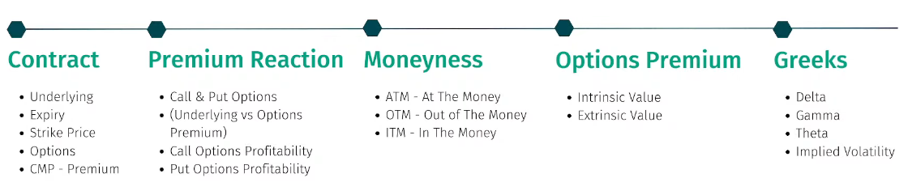

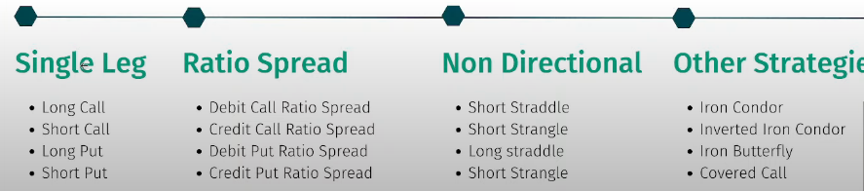

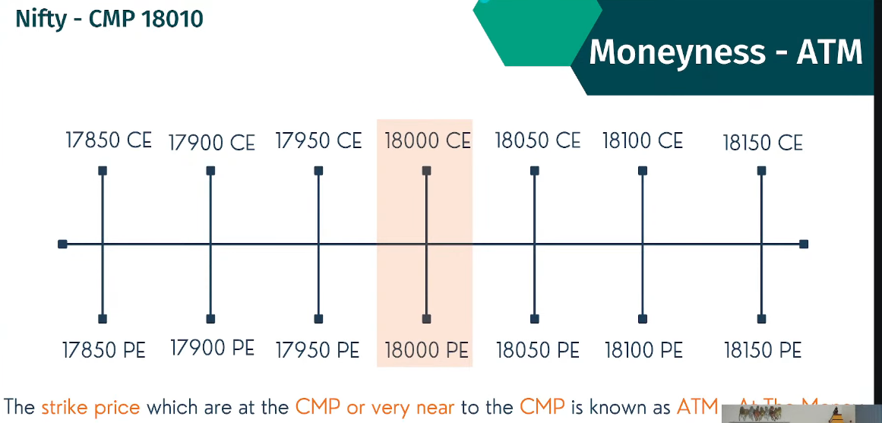

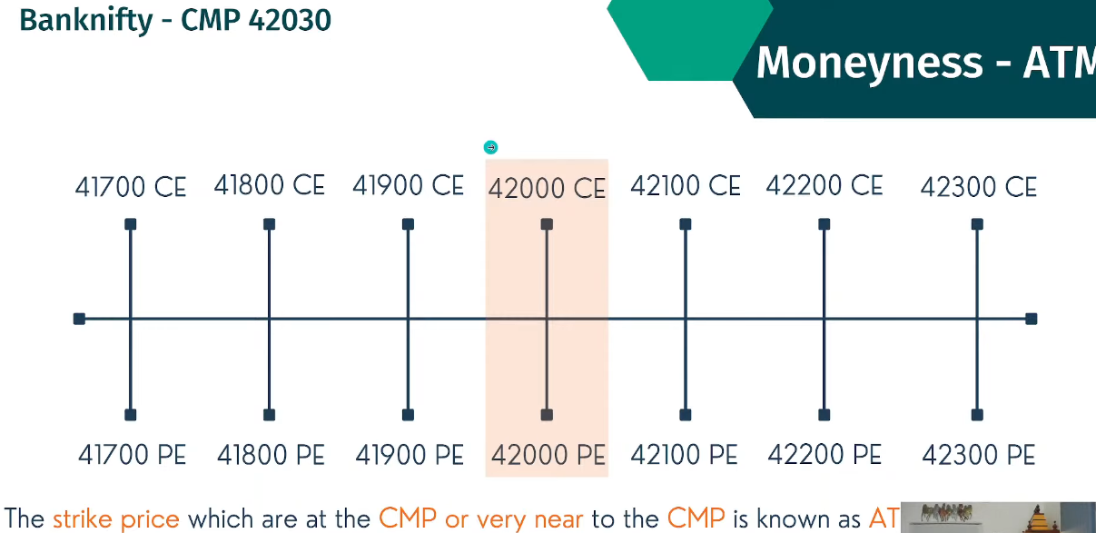

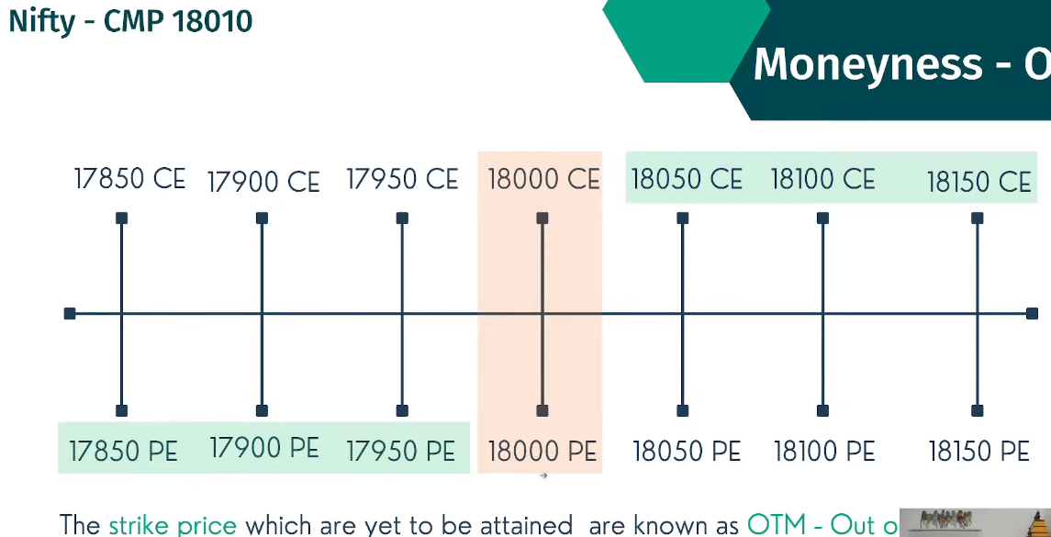

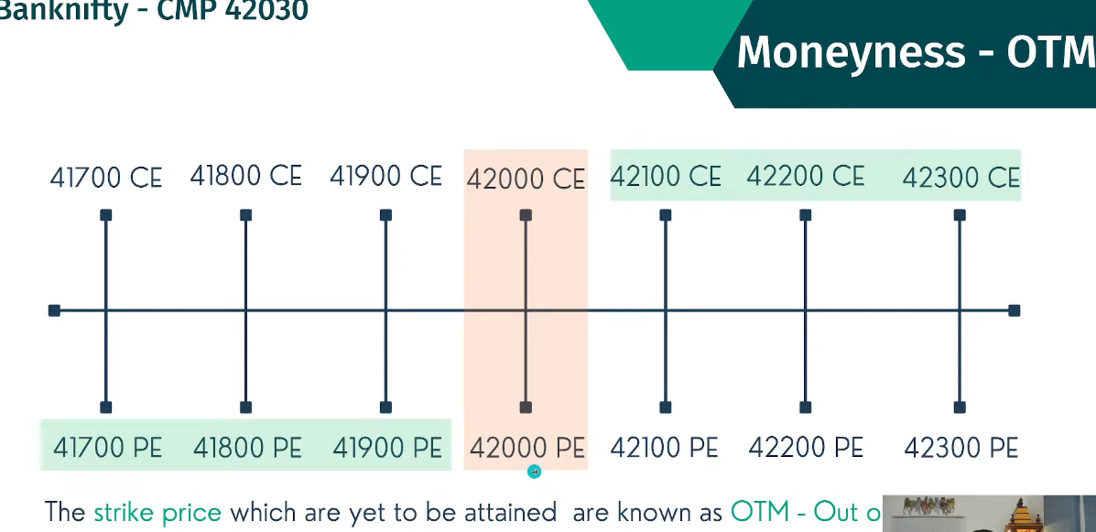

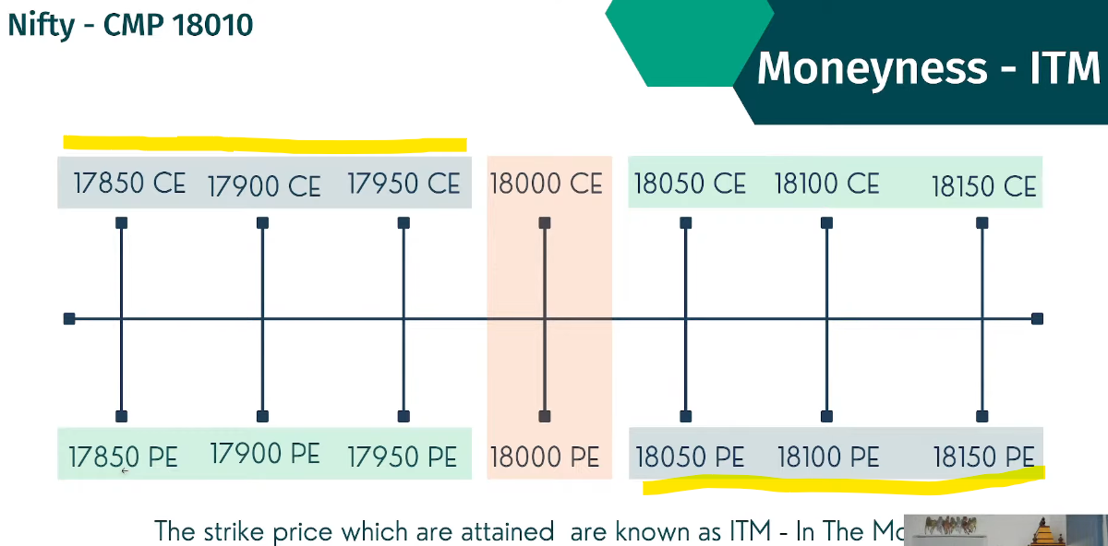

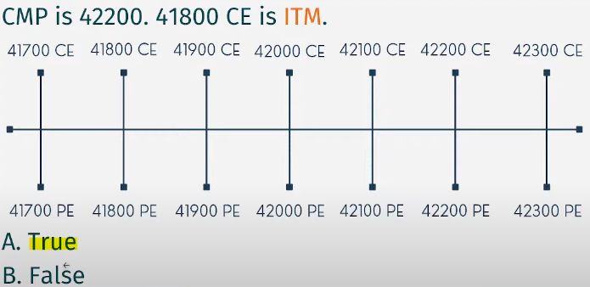 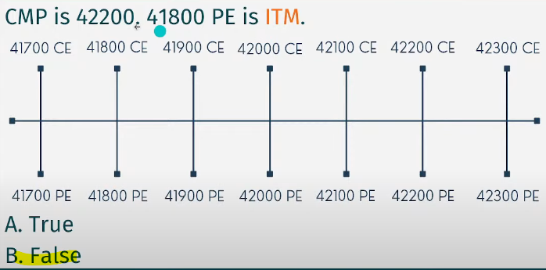

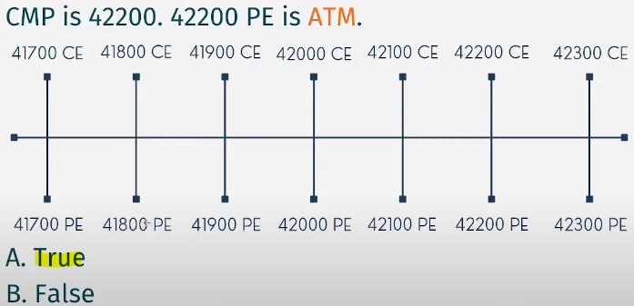 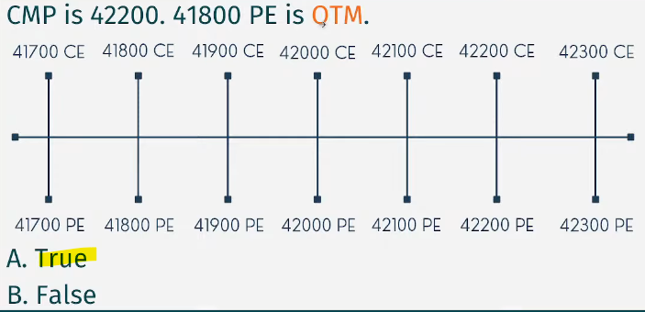

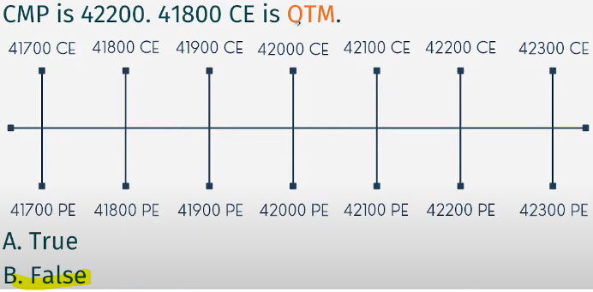

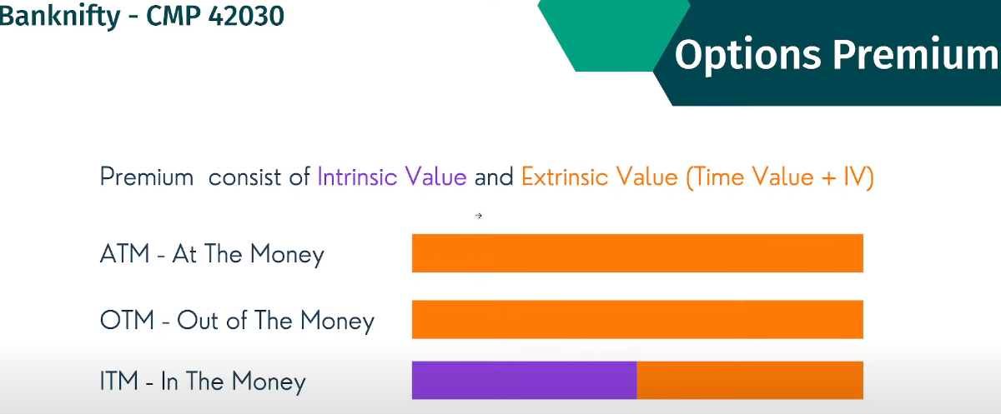

Sometimes even though market went high, but call option may be in loss.

Intrinsic premium – does not dissolve or go low

Extrinsic value – dissolving value

ITM – HAVE BOTH VALUE

ATM & OTM HAVE EXTRINSIC VALUE ONLY

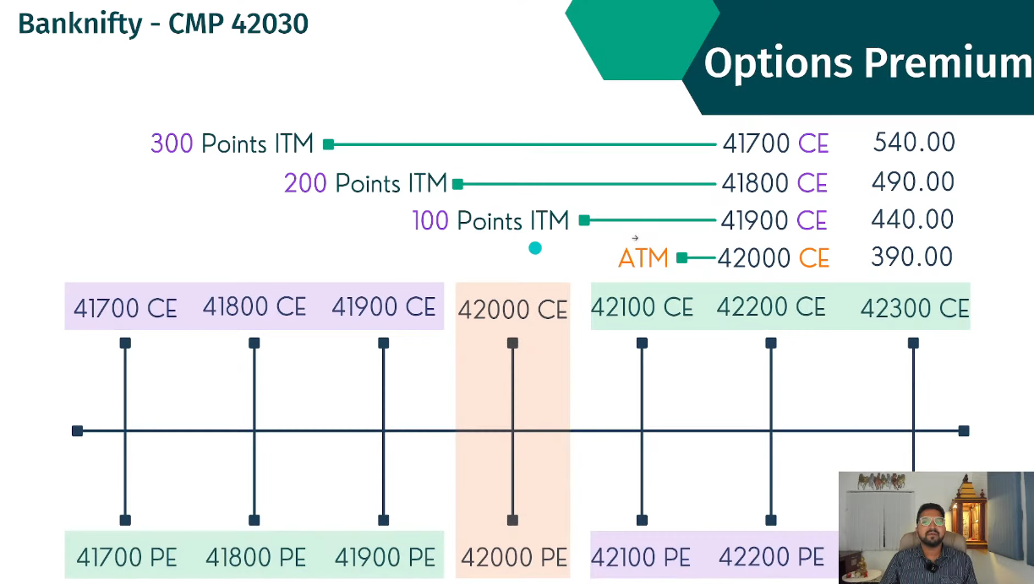

ITM 41900CE – 440 IS PREMIUM, 100 POINTS

Since it is 100 points, actual value is 100 which in intrinsic value and remaining 340 which is extrinsic value

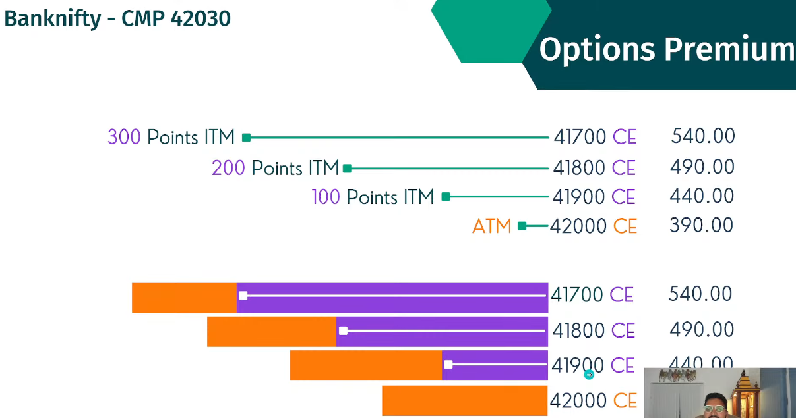

At expiry, Extrinsic value dissolve and goes to zero.

41900 CE – 440 PREIMIUM – 100 POINTS ITM – BEFORE EXPIRY (100 INTRINSIC VALUE AND 340 EXTRINSIC VALUE WHICH DISOLVES DURING EXPIRY)

41900 CE – 100 PREIMIUM – 100 POINTS – AT EXPIRY (340 NULLIFIED AND ONLY INTRINSIC VALUE IS PRESENT ON EXPIRY)

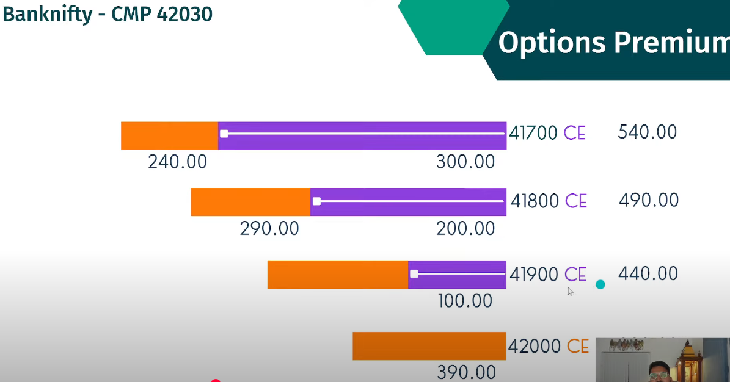

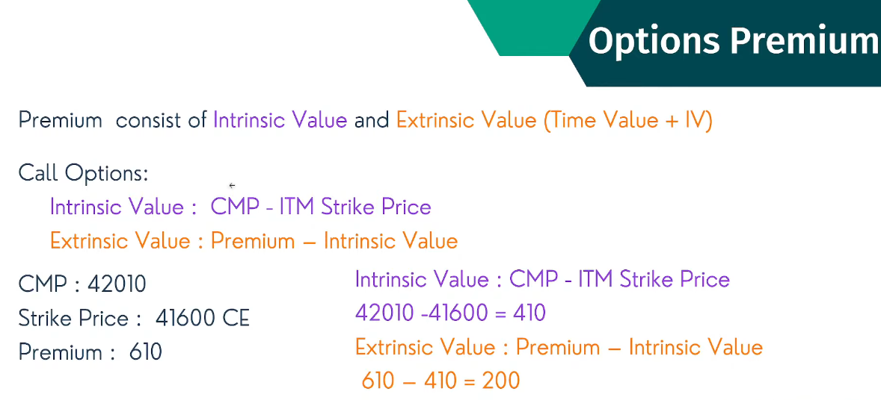

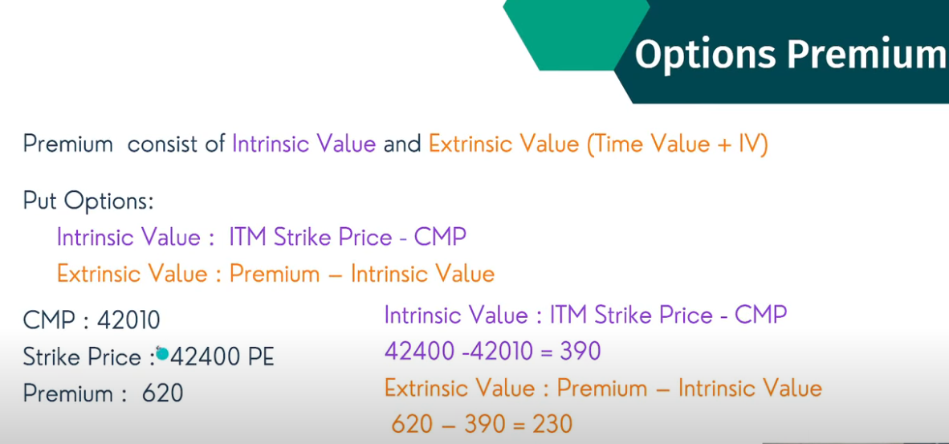

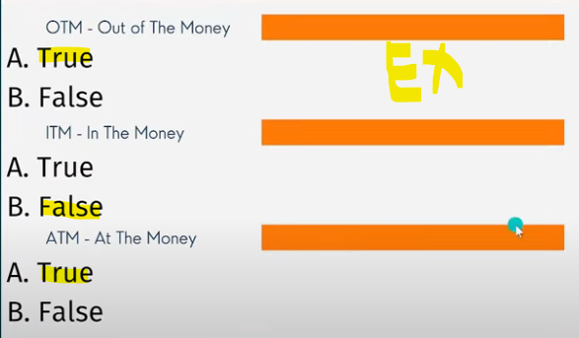 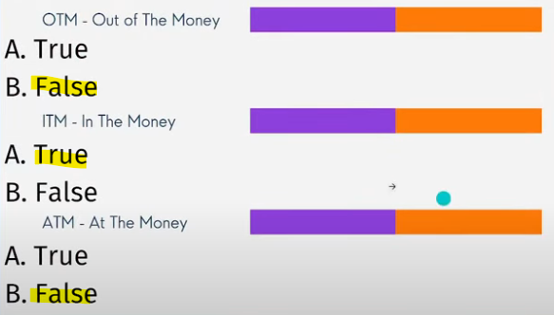

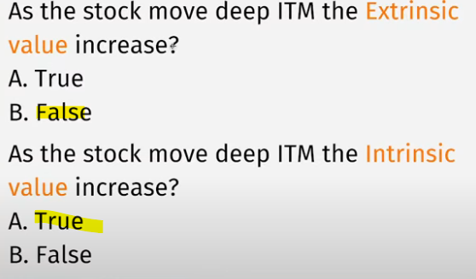

At expiry all extrinsic values (orange in color) will become zero like 2nd screenshot below

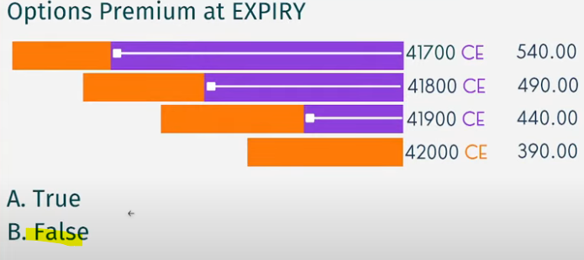 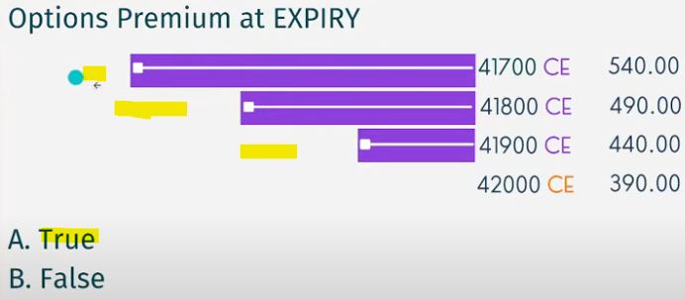

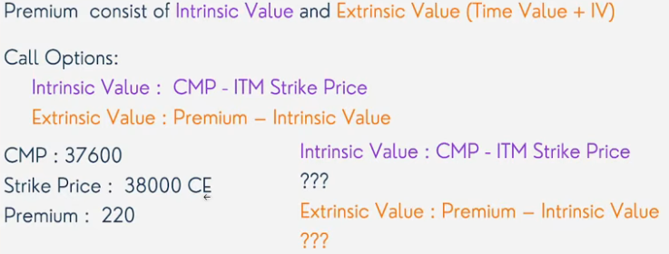 38000 CE IS OTM FOR CMP, IV – 0, EV – 220

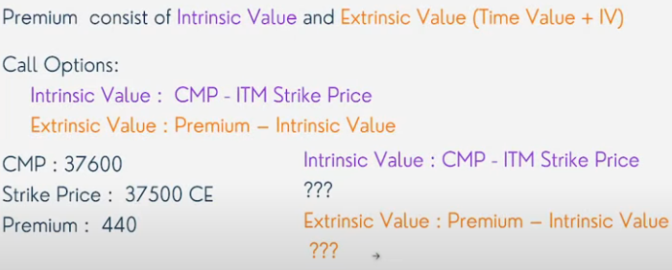 37500 CE IS ITM FOR CMP, IV = 100, EV = 340

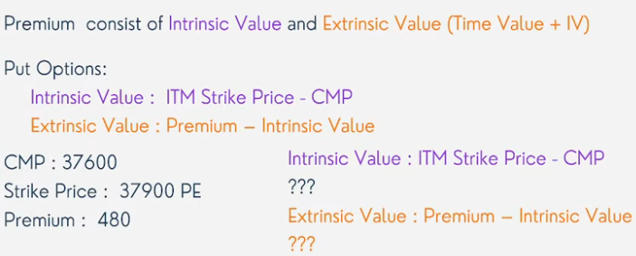 37900 PE IS ITM FOR CMP, IV = 300, EV = 180

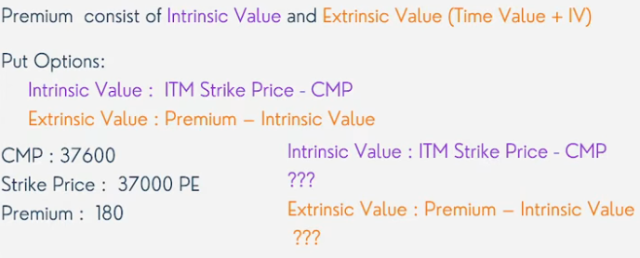37000 PE IS OTM FOR CMP, IV = 0, EV = 180